**ASSIGNMENT**

**MODULE-3**

**CLOUDWATCH DASHBOARD**

**Done By**

**RANJITH KUMAR**

**Tasks To Be Performed:**

1. Create a dashboard which lets you check the CPU utilization and

networking for a particular EC2 instance.

**STEP 1 :** Create a EC2 instance

**STEP 2 :** Open Cloudwatch from the aws services

**STEP 3 :** Click on Dashboards > Create Dashboard

**STEP 4 :** Give name to the Dashboard

**STEP 5 :** From add widget page select the widget how it should be viewed.

**STEP 6 :** Copy and paste the instance id from EC2 in add metric graph page

**STEP 7 :** Select Cpu utilization and network from browse tab and click create widget

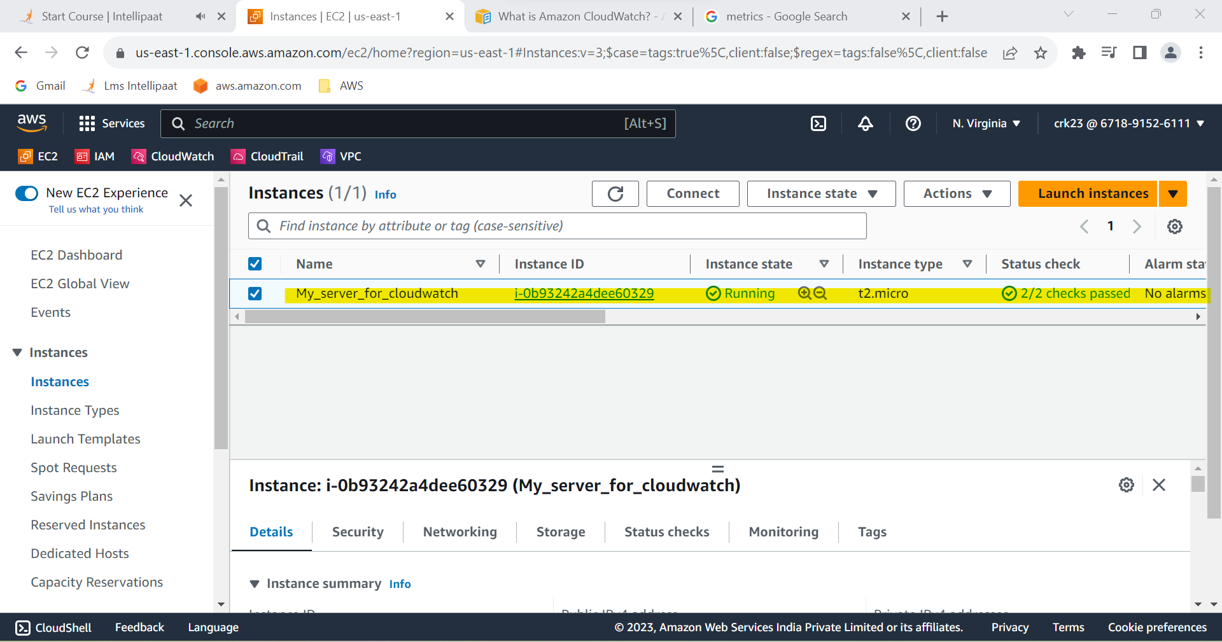

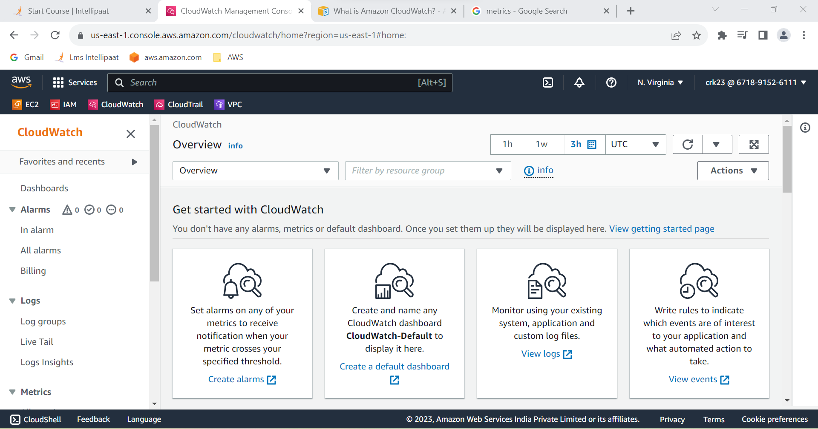

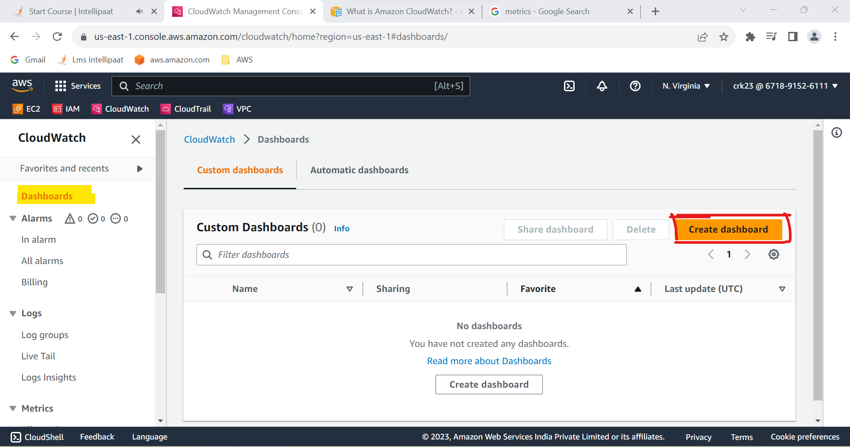

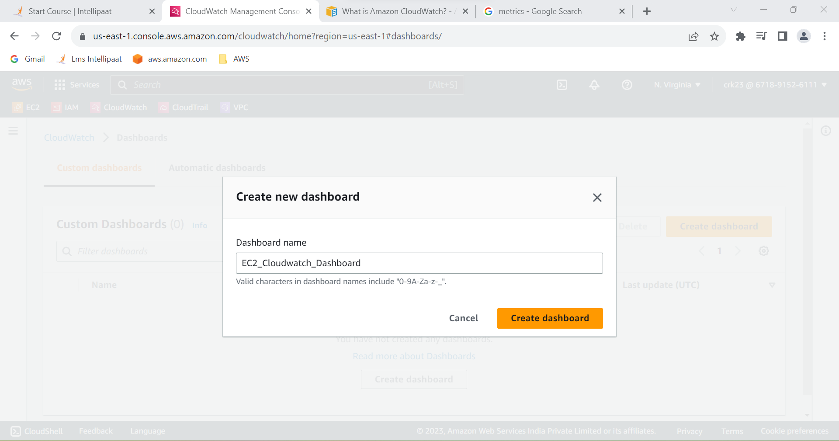

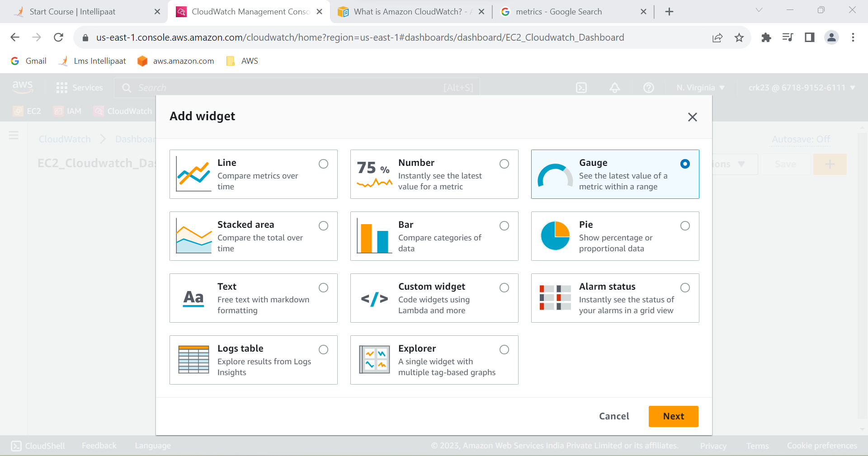

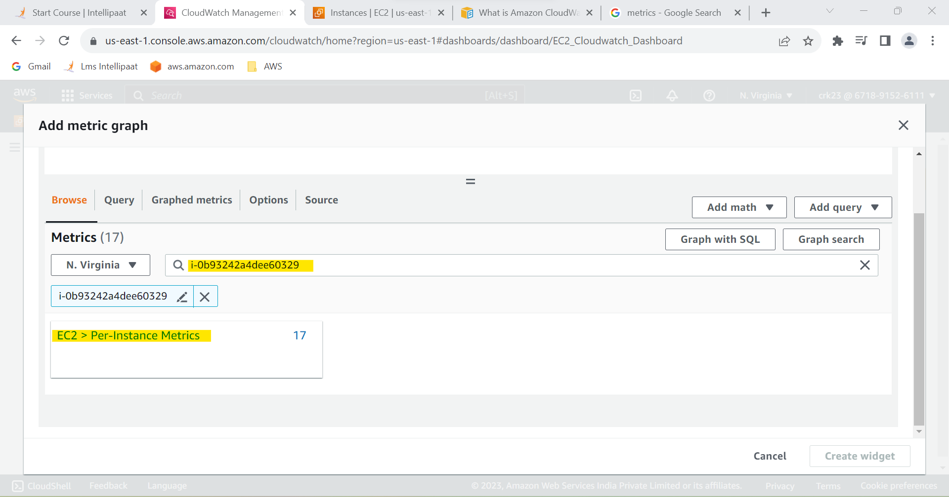

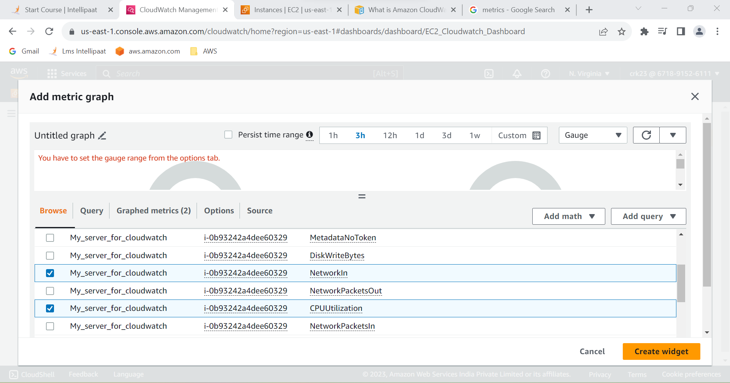

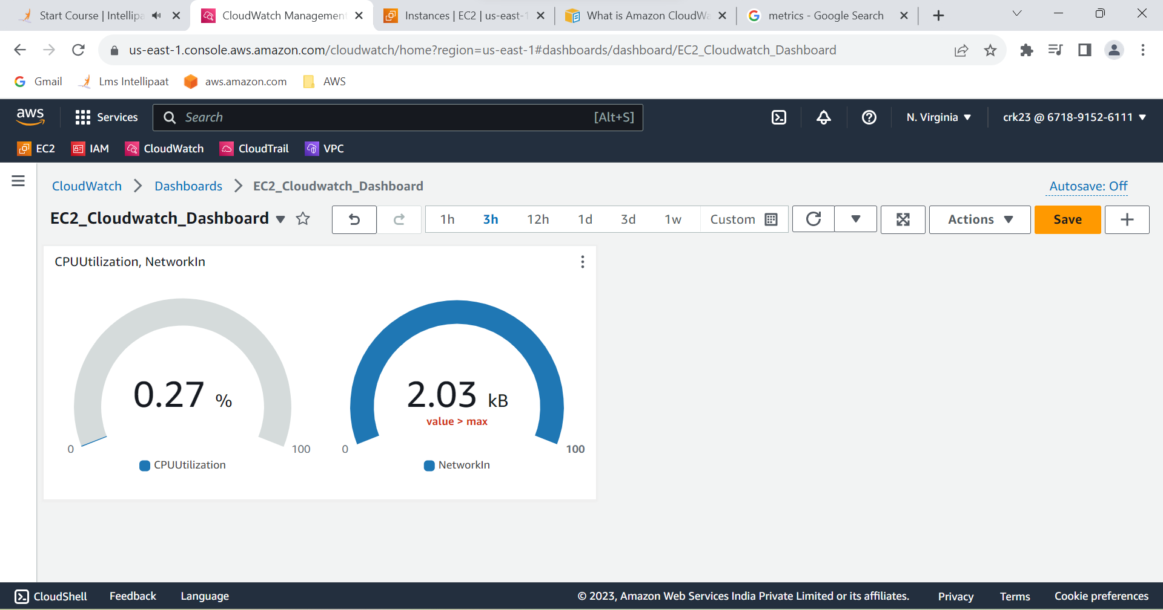

**TASK OUTPUT :**

Dashboard has been created to check the CPU utilization an

networking for a particular EC2 instance.